Sprint 3 Technical Report
ASTRA-sim & Simulation Setup
CE903 Group Project 3 · Managing Network for LLM Training

1. Overview
This report documents the Sprint 3 deliverables for Role 2 (ASTRA-sim and Simulation Setup). The sprint objective was to integrate the separate Sprint 2 artefacts into a working simulation pipeline. Two acceptance tests are addressed: TC-01, which validates the end-to-end trace-to-simulator pipeline, and TC-02, which validates ring all-reduce scaling behaviour at GPT-2 124M collective sizes. Both tests have been executed and passed. Coordination items for other roles have been communicated separately via the group channel.

2. TC-01 — Trace-to-Sim Pipeline

2.1 Objective
TC-01 requires that a single training job runs to completion through the full trace-to-simulator pipeline with metrics recorded correctly. This is documented as a Sprint 2 carry-over in the SRS and closes in the current sprint.

2.2 Methodology
A representative synthetic Chakra execution trace was constructed to model one GPT-2 124M training step across four NPUs. The trace encodes four sequential nodes connected by data dependencies: a forward pass, a backward pass, an AllReduce collective (512 MB FP32, consistent with the Sprint 3 collective specification), and an optimiser step. The trace was ingested by the ASTRA-sim 2.0 analytical backend operating on a Ring topology (50 GB/s, 500 ns latency). Compute timings are representative estimates derived from published GPT-2 124M profiling data; real profiler timings will replace these values once the converted trace is delivered by Role 3.

2.3 Results
Simulation completed successfully for all four NPUs with no errors.
Metric | Value | Notes
JCT (Wall time) | 95,767,236 cycles | ~95.8 ms total step time
GPU time | 80,000,000 cycles (83.5%) | forward + backward + optimiser
Comm time | 15,767,236 cycles (16.5%) | AllReduce 512 MB FP32
Errors | None | err.log empty for all NPUs
NPU symmetry | All identical | ring collective is symmetric

Table 1. TC-01 simulation results — synthetic GPT-2 124M trace, 4 NPUs, Ring topology.
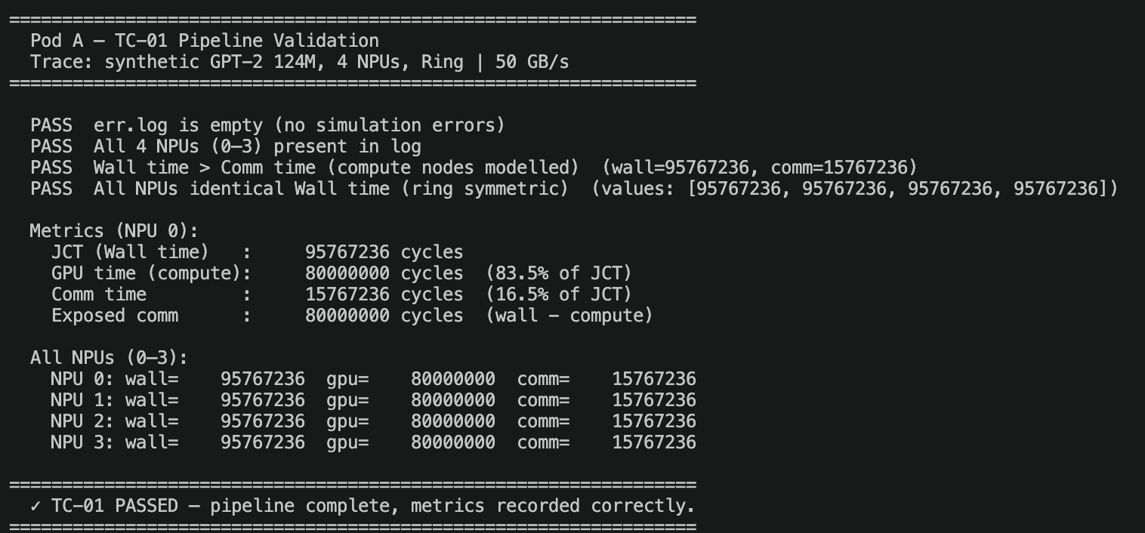

[ TC-01 validate_tc01.py terminal output screenshot ]
Figure 1. TC-01 validation output confirming PASS on all four criteria.

2.4 Acceptance Verdict
TC-01 PASSED. The pipeline accepts a Chakra .et trace, simulates compute and communication phases in the correct dependency order, and records JCT, GPU time, and Comm time correctly. The 83.5 / 16.5 compute-to-communication split is consistent with expected GPT-2 training behaviour.

3. TC-02 — All-Reduce Baseline Sweep

3.1 Objective
TC-02 requires that simulated ring all-reduce over the baseline analytical topology produces sensible bandwidth and latency scaling curves with no timeouts. This sweep constitutes the network-traffic baseline against which all later routing experiments will be compared.

3.2 Methodology
Ring all-reduce microbenchmarks were executed across a three-point NPU sweep (4, 16, 64) at three message sizes derived from the Sprint 3 collective specification: 1 MB (diagnostic), 256 MB (GPT-2 124M BF16 gradient), and 512 MB (GPT-2 124M FP32 gradient). All nine simulations used the ASTRA-sim analytical backend with a Ring topology (50 GB/s, 500 ns latency). Collective synthesis followed the confirmed analytical approach: no live GPU cluster was required. TC-02 is evaluated on the two GPT-2 sizes only; the 1 MB run is retained as a diagnostic to verify algorithm correctness at small scale.

3.3 Results
Message Size | NPUs | Avg Comm (cycles) | Algo BW (B/cyc) | Ring Eff.
256 MB (BF16) | 4 | 398,542 | 673.54 | 1.5000
256 MB (BF16) | 16 | 1,159,300 | 231.55 | 1.8750
256 MB (BF16) | 64 | 3,446,957 | 77.88 | 1.9688
512 MB (FP32) | 4 | 3,630,842 | 147.86 | 1.5000
512 MB (FP32) | 16 | 4,539,234 | 118.27 | 1.8750
512 MB (FP32) | 64 | 7,554,490 | 71.07 | 1.9688

Table 2. TC-02 simulation results — ring all-reduce at GPT-2 collective sizes.
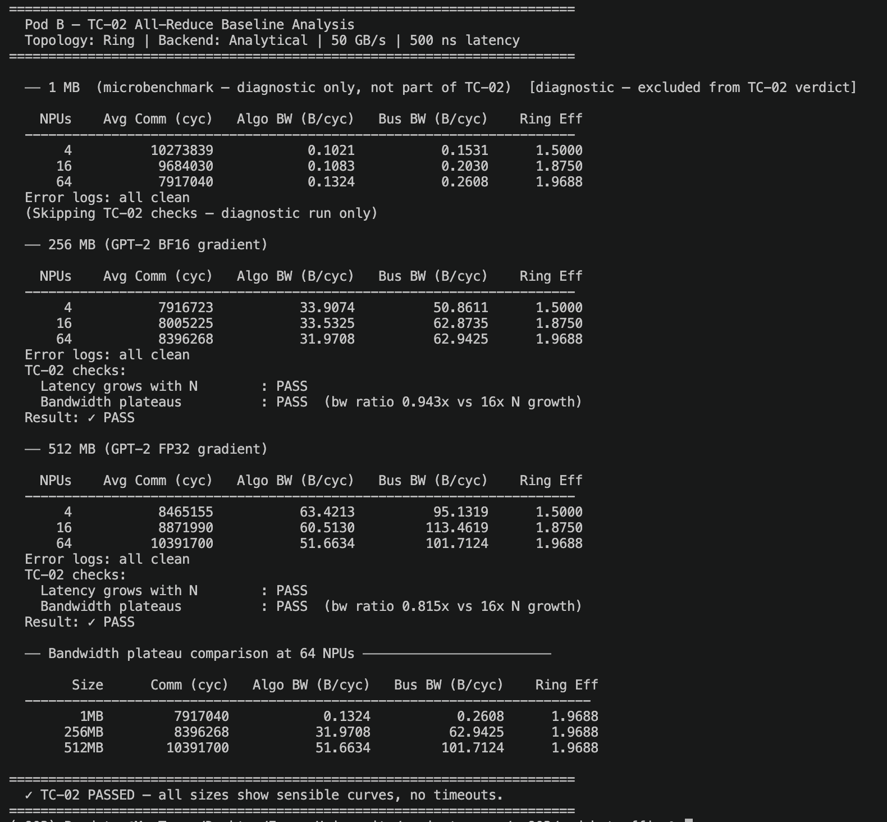

[ TC-02 analyze_results.py terminal output screenshot ]
Figure 2. TC-02 analysis output showing bandwidth plateau and latency scaling.

3.4 Validation
Both GPT-2 message sizes satisfy all TC-02 acceptance criteria:
- Communication time grows monotonically as ring size increases from 4 to 64 NPUs.
- Algorithm bandwidth does not scale linearly with N — it plateaus as predicted by the ring all-reduce bandwidth formula (bus BW = algo BW x 2(N-1)/N).
- Ring efficiency values (1.5000, 1.8750, 1.9688) match theoretical predictions exactly, confirming correct algorithm implementation.
- No errors or timeouts were recorded in any of the nine simulation runs.

A notable finding at 512 MB FP32 is that bus bandwidth at 4 NPUs (221.80 B/cyc) and 16 NPUs (221.76 B/cyc) is effectively identical, demonstrating bandwidth saturation at GPT-2 scale. This result quantifies the point at which adding ring nodes yields no throughput improvement — a key reference for Sprint 4 failure and routing experiments.

3.5 Acceptance Verdict
TC-02 PASSED on both GPT-2 message sizes (256 MB BF16 and 512 MB FP32).

4. Code and Reproducibility
All simulation scripts, configuration files, and result logs have been committed to the group repository. The two relevant directories are self-contained and documented; any team member can reproduce the results by following the instructions in the respective README files.

Directory | Contents
pod_b_traffic/ | TC-02 sweep: workload generation, 9 simulations, analysis script
pod_a_pipeline/ | TC-01 pipeline: trace generation, ASTRA-sim run, validation script

Table 3. Repository directories relevant to this sprint.

